**Physics 30 Lessons 1 to 24 Review**

1. A 1.1 × 103 kg car travelling at a velocity of 10.0 m/s collides head-on with a brick wall. If the car comes to a complete stop in 0.25 s, what was the average force exerted on the car during the collision? (-44000 N)
2. If a 0.15 kg object has 9.0 J of kinetic energy, what is the magnitude of its momentum? (1.6 kg m/s)
3. A 0.45 kg ball travels with a velocity of 11.0 m/s east when it hits a wall. If the ball rebounds with a velocity of 10.0 m/s west, what was the impulse of the wall on the ball? (9.5 kg m/s [west])
4. A car moving with a velocity of 10.0 m/s east collides with a stationary truck with exactly twice the mass of the car. If the two vehicles lock together, calculate the velocity of their combined mass immediately after collision. (3.33 m/s)
5. A 7.0 kg object moving north with an unknown velocity collides with a 5.0 kg stationary object. After the collision, the 7.0 kg object moves with a velocity of 3.0 m/s @ 30.0˚ E of N, and the 5.0 kg object moves with a velocity of 5.0 m/s @ 25.0˚ W of N.
   1. Calculate the velocity of the 7.0 kg object before collision. (5.83 m/s)
   2. Is this an elastic or inelastic collision? Provide mathematical evidence for your answer. (inelastic)
   3. What happened to the kinetic energy that was lost?
6. If a ray of light strikes a mirror at an incident angle of 58˚, what is the angle between the reflected ray and the mirror?
7. The speed of light in a clear liquid is 2.30 × 108 m/s. What is it’s index of refraction?

(n = 1.3)

1. The critical angle for a certain liquid-air interface is 48.8˚. What is the liquid’s index of refraction? (n = 1.33)
2. A ray of light in air strikes a side of an equilateral Lucite prism (n = 1.50) at an angle of 54˚ to the face of the prism. Find the angle to the prism at which the light leaves the prism. (25.7˚)
3. A 3.0 cm tall object is placed 6.0 cm in front of a mirror. If a 1.0 cm tall virtual image is produced, what is the focal length of the mirror? What kind of mirror is it? (-3.0cm, convex)
4. An object is placed 5.0 cm in front of a concave mirror. The magnification of the object is 2.5. If a real image is produced, what is the radius of curvature of the mirror? (7.1 cm)
5. A glowing 2.0 cm tall object is placed 5.0 cm from a lens. If a virtual image is produced that is 4.0 cm tall, what is the focal length of the lens? What kind of lens is used? (10cm, convex)
6. A 3.0 cm tall object produces a virtual image that is 2.0 cm tall. If the image is 3.0 cm from the lens, what is the focal length of the lens? What kind of lens is used? (9.0cm, concave)
7. An object is 8.0 cm from a concave lens that has a focal length of 4.0 cm. What is the magnification of this object? (m = 1/3)
8. If the second-order minimum occurs at an angle of deviation of 16.0˚ when light with a wavelength of 530 nm is used, how many lines/metre does the diffraction grating have? (3.47 × 105)
9. A diffraction grating with lines 0.030 mm apart produces an interference pattern on a screen 1.00 m away. If the maxima are 1.7 cm apart, what is the frequency of the light used? (5.9 × 1014 Hz)
10. The fact that light can be polarized indicates that light is a ___________ wave.
11. Two point charges produce an electric force on each other of 4.5 mN. What is the electric force if the charge on both objects triple and the distance between them doubles? (0.010 N)
12. Two small spheres have the same mass and volume. One of the spheres has a charge of 4.00 μC and the other sphere has a charge of -1.00 μC. If these two spheres are brought into brief contact with each other and then separated to a distance of 20 cm, what is the electrostatic force between them? When the spheres are brought together, this is called charging by ___________. (0.0506 N)
13. What is the initial acceleration on an alpha particle when it is placed at a point in space where the electric field strength is 7.60 × 104 N/C. (3.66 × 1012 m/s2)
14. Calculate the electric field strength midway between a 3.0 μC charged object and a 6.0 μC charged object if the objects are 80 cm apart. (1.7 × 105 N/C)
15. At a distance of 0.750 m from a small charged object, the electric field strength is 2.10 × 104 N/C. At what distance from this same object would the electric field strength be 4.20 × 104 N/C. (5.30 × 10-1 m)
16. An alpha particle gained 1.50 × 10-15 J of kinetic energy when it passed through a potential difference. What was the magnitude of the potential difference that accelerated the particle? (4687.5 V)
17. A proton is placed in an electric field between two parallel plates. If the plates are 6.0 cm apart and have a potential difference between them of 750 V,
    1. how much work is done against the electric field when the proton is moved 3.0 cm parallel to the plates? (0)
    2. how much work is done against the electric field when the proton is moved 3.0 cm perpendicular to the plates? (6.0 × 10-17 J)
18. An alpha particle with an initial speed of 7.15 × 104 m/s enters into an electric field between two parallel plates through a hole in the positive plate. If the distance between the plates is 9.0 cm and the electric field is 170 V/m, what will be the alpha particle’s speed when it reaches the negative plate? (8.11 × 104 m/s)
19. What is the potential difference between two parallel charged plates that are 7.50 cm apart if a force of 5.30 × 10-14 N is needed to move an alpha particle from the negative plate to the positive plate? (12 421.9 V)
20. In Millikan’s oil-drop experiment, an oil drop with a mass of 7.20 × 10-16 kg moves upward with a constant speed of 2.50 m/s between two horizontal, parallel plates. If the electric field strength between these plates is 2.20 × 104 V/m, what is the magnitude of the charge on the oil drop? (3.21 × 10-19 C)



1. An electron travelling horizontally at a speed of 8.70 × 106 m/s enters into an electric field of 1.32 × 103 N/C between two horizontal parallel plates, as described in the diagram on the right. Calculate the vertical displacement of the electron as it travels between the plates. (3.00 cm)
2. What is the magnitude and direction of a magnetic field that produces a downward force of 7.30 × 10-13 N on a proton that travels through the field with a velocity of 7.80 × 107 m/s east? (5.85 mT out of page)
3. A potential difference accelerates an alpha particle from rest, which then travels perpendicularly through a magnetic field of 550 mT where it experiences a magnetic force of 6.20 × 10-14 N. What is the potential difference through which it is accelerated?

(1.29 kV)

1. A 75.0 cm long conductor carries a conventional current of 2.0 A vertically downward through a magnetic field of 2.7 mT magnetic field directed out of the page. What is the magnitude and direction of the magnetic force acting on the conductor? (4.1 mN west)
2. A current balance is used to determine the magnetic field intensity in the core of a solenoid. Side WX is 6.3 cm long and side XY is 1.5 cm long. The current flowing through the solenoid is 5.0 A and the current flowing through wire WXYZ is 0.45 A. If the current balance is balanced by a 23 ng mass, what is the magnetic field strength in the solenoid core? (0.0334 T)

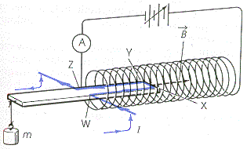

1. Ions travelling at a velocity of 3.50 × 107 m/s pass undeflected through the velocity selector in a mass spectrometer. If the magnetic field strength in the velocity selector is 500 mT, what is the electric field strength in the velocity selector? (1.75 × 107 N/C)
2. Singly charged ions pass undeflected through the velocity selector of a mass spectrometer. This velocity selector has a magnetic field strength (250 mT) and an electric field (7000 V/m) which are perpendicular to each other. These ions then enter the ion separation chamber where the magnetic field has the same strength as in the velocity selector. If the radius of the deflected ions is 0.812 cm, what is the mass of each ion? (1.16 × 10-26 kg)
3. In a mass spectrometer, a velocity selector allows singly charged carbon-14 atoms with a velocity of 1.00 × 106 m/s to travel undeflected through the selector. When these ions enter the ion separation region with a magnetic field strength of 0.900 T, what will be the radius of the ions’ path? (16.2 cm)
4. Who developed the EMR theory?
5. Oersted and Faraday established the two basic principles of electromagnetism. Briefly describe each of their principles.
6. In 1886 ______________ used an induction coil to detect EMR. He is credited with successfully producing and detecting electromagnetic waves.
7. The speed of all EMR is _____________. The greater the _____________ of EMR, the greater its energy.
8. All EMR is produced by accelerating ______________ particles.

* Radio waves, including television signals and microwaves are produced by the _______________ of electric current.
* __________________ is produced by molecular vibrations.
* Visible light and ultraviolet light is produced by the transitions of ____________ in atoms.
* _____________ are produced by high energy electrons undergoing rapid deceleration by hitting a target.
* Gamma rays are produced by ___________________________________.

1. An experiment was conducted to find the speed of a microwave. The frequency of a microwave transmitter is 1.05 × 1010 Hz. The distance between 10 nodes on a microwave detector was measured to be 14.5 cm. What is the experimental speed of a microwave?

**Old diploma exam questions**

*Use the following information to answer the next three questions.*

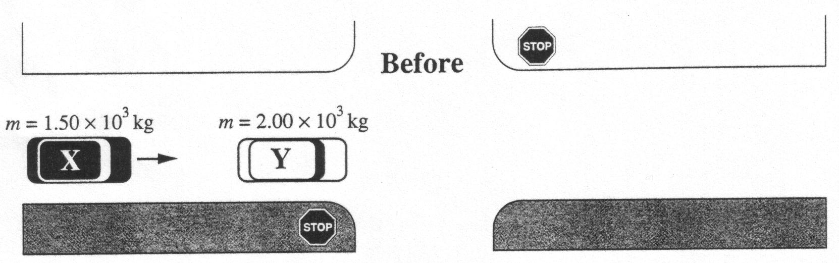

A police officer's investigation of an accident involving a collision between vehicles **X** and **Y** provided the following information:

1. a test on the road surface with a 2.00 x 103 kg vehicle showed that the vehicle slowed down at the rate of 5.00 m/s2 due to friction

2. each vehicle, **X** and **Y**, received some damage

3. after impact, vehicle **Y** traveled 19.6 m before stopping

4. vehicle **X** did not have the brakes applied before the collision

5. vehicle **Y** was stationary before the collision

6. vehicle **X** was stationary after the collision

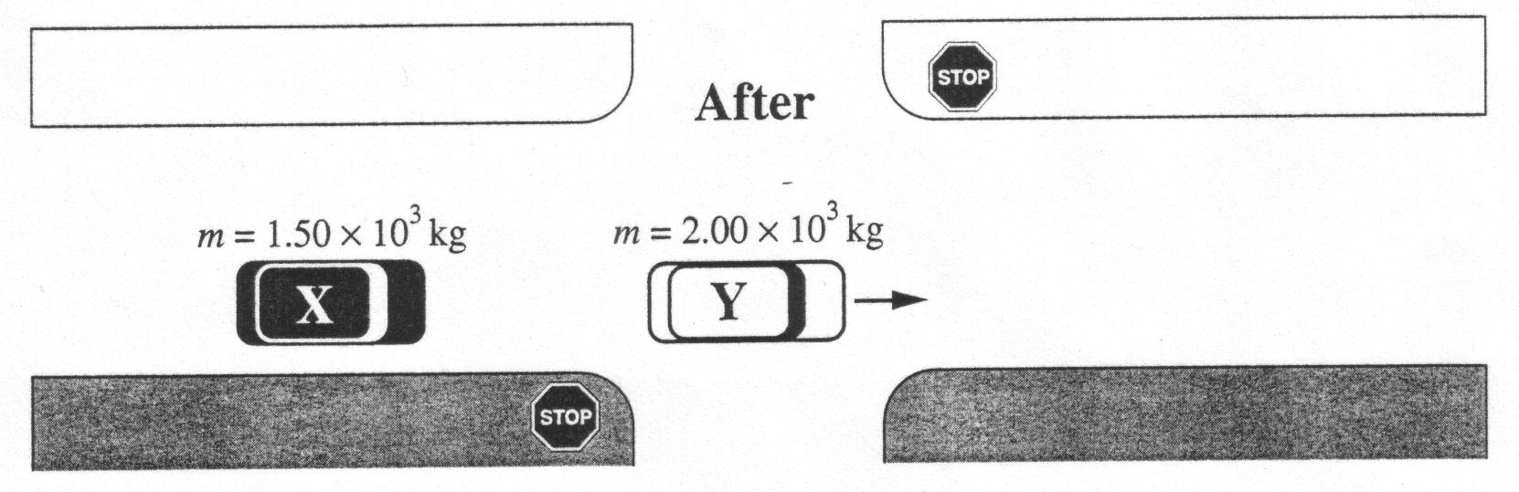

1. What was the speed of vehicle **Y** just after the collision?

A. 19.6 m/s

B. 14.0 m/s

C. 11.0 m/s

D. 1.56 m/s

*Use your answer from* ***Multiple Choice 1*** *to answer* ***Numerical Response 1***

Numerical Response

1. Immediately before the collision, the speed of vehicle **X** was __________ m/s.

(Record your **three‑digit answer** in the numerical‑response section on the answer sheet.)

1. In analyzing the scene of the accident, the officer most often applied her understanding of

A. Newton's First Law

B. Newton's Second Law

C. the Law of Conservation of Energy

D. the Law of Conservation of Momentum

_____________________________

1. A tennis ball with a mass of 110 g is travelling 18.5 m/s east. It is struck by a racquet that applies a force of 950 N west. The ball and the racquet are in contact for 3.20 ms. The change in momentum of the tennis ball is

A. 2.04 kg·m/s, west

B. 3.04 kg·m/s, west

C. 2.04 × 103 kg·m/s, west

D. 3.04 × 103 kg·m/s, west

*Use the following information to answer the next question.*

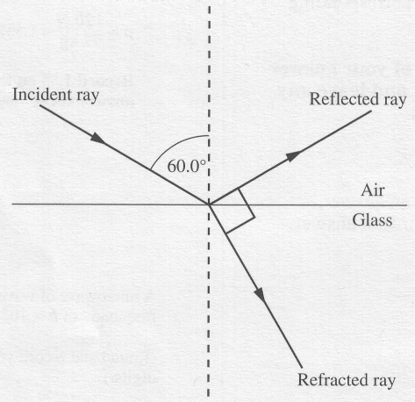

A light ray in air is incident upon a glass surface at an angle of incidence of 60.0°. Part of the light is reflected and part is refracted at the air-glass interface. The angle between the reflected ray and the refracted ray is 90.0°.

Numerical Response

1. The refractive index of the glass is _____ .

(Record your **three‑digit answer** in the numerical‑response section on the answer sheet.)

_______________________________

Numerical Response

1. When light with a frequency of 6.00 × 1014 Hz enters a certain type of glass, its speed changes to 2.29 × 108 m/s. The wavelength of the light in the glass, expressed in scientific notation, will be ***a*.*bc*** × 10-***d*** m. The of ***a***, ***b***, ***c*** and ***d*** are ___, ___, ___, and ___.

(Record your **four-digit** answer in the numerical‑response section on the answer sheet.)

*Use the following information to answer the next question.*

35o

water

substance X

29o

Numerical Response

1. The speed of light in water is 2.26 × 108 m/s. Light passes from water into substance X with an angle of incidence of 35.0o, producing an angle of refraction of 29.0o. The speed of light in substance X, expressed in scientific notation, is ***a****.****bc*** × 10***d*** m/s. The values of ***a***, ***b***, ***c*** and ***d*** are _____, _____, _____, and _____.

(Record your **four-digit** answer in the numerical‑response section on the answer sheet.)

_______________________________________

1. The electric field between a positive point charge and a negative point charge is represented by

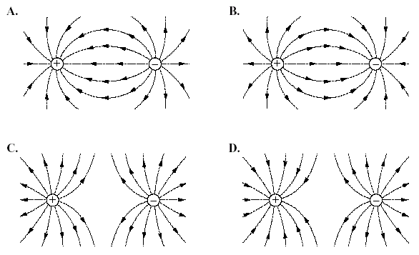

*Use the following information to answer the next question.*

**Linear Accelerator**

The following is a simplification of what takes place when charged particles are accelerated and collisions take place. To accelerate alpha particles, charged parallel plates may be used. The magnitude of the electric field between two charged parallel plates at a **fixed** distance *d* apart can be calculated for different distances *x* from the positive plate.

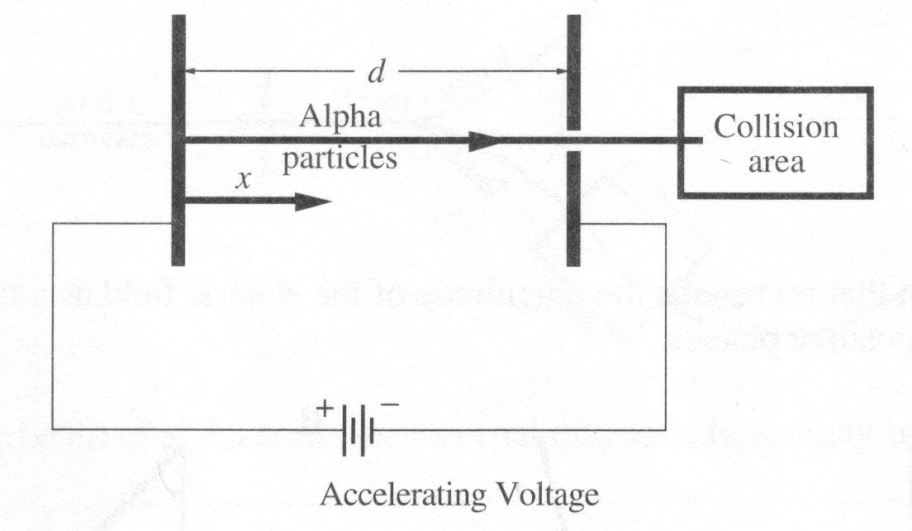

In the collision area, the incoming alpha particles moving at 8.07 × 106 m/s collide with other alpha particles that are at rest. Assume that each collision involves two alpha particles in an inelastic collision that form a new  (beryllium) nucleus.

1. What is the final momentum of the new  nucleus?

A. 1.07 × 10‑19 kg·m/s

B. 5.37 × 10‑20 kg·m/s

C. 2.68 × 10‑20 kg·m/s

D. 1.35 × 10‑20 kg·m/s

______________________________

*Use the following information to answer the next three questions.*

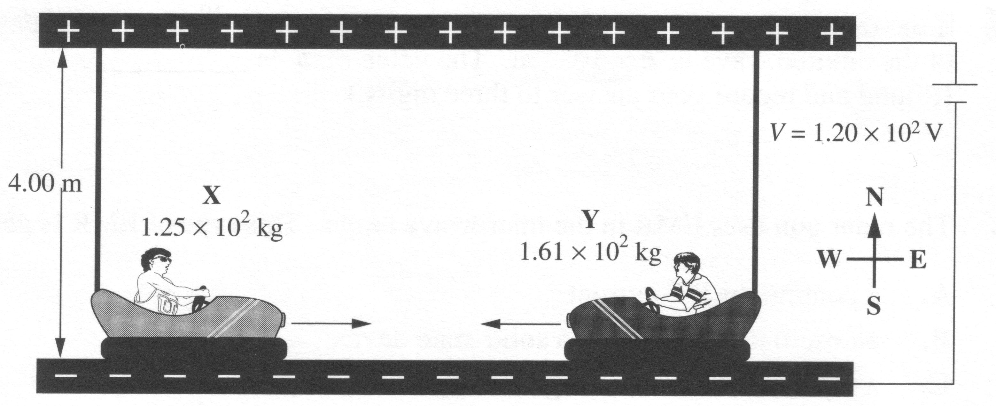

Bumper cars operate on electricity. The more the accelerator pedal is pressed, the more current flows in the system, thus the faster the car travels. Car **X** and car **Y** are going to collide head-on. Car **X** is travelling at a constant velocity of 2.25 m/s to the east and car **Y** is travelling at a constant velocity of 1.30 m/s to the west.

1. If after the collision car Y is travelling at 0.526 m/s to the east, the velocity of car X immediately after impact would be

A. 1.02 × 10-1 m/s to the west

B. 3.25 m/s to the east

C. 4.60 m/s to the east

D. 1.02 × 101 m/s to the west

1. The electric field between the top and bottom grids of the system is

A. 30.0 N/C up

B. 30.0 N/C down

C. 480 N/C up

D. 480 N/C down

1. The graph that represents the magnitude of the electric field as a function of the distance x from the positive plate is

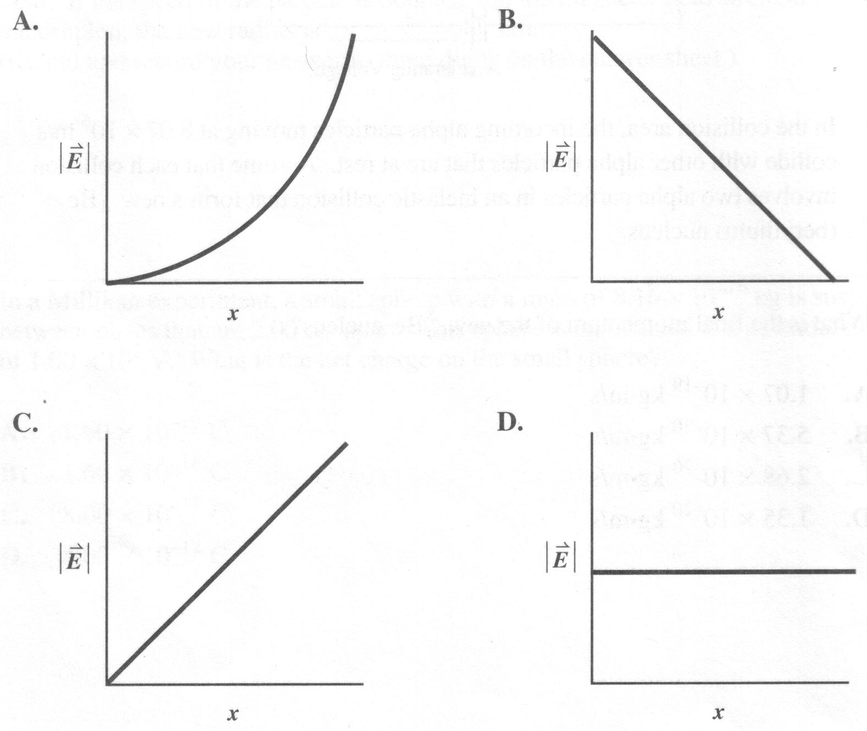

______________________________

1. Which graph **best** represents the magnitude of the electrostatic force, *F*, as a function of the distance, *r*, between two point charges?

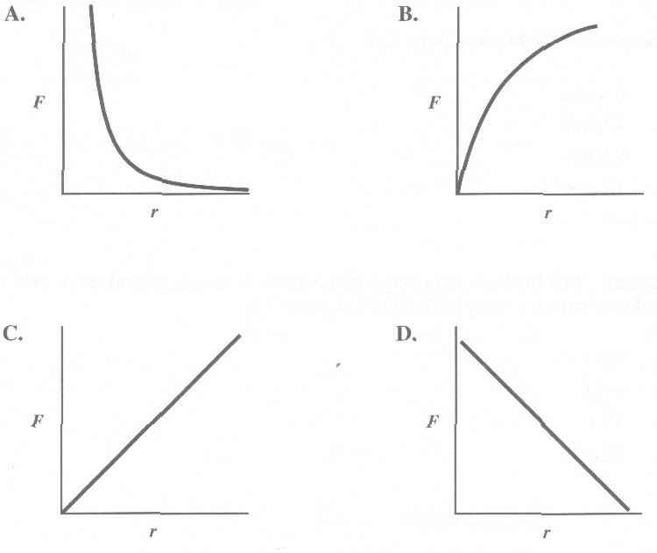

*Use the following information to answer the next question.*

A positively charged rod is placed near, but not touching, a neutral metal ball.

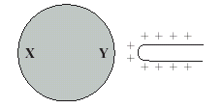

1. As a result of the rod’s position, side X of the ball becomes relatively

A. negative and the ball is repelled from the rod

B. positive and the ball is repelled from the rod

C. negative and the ball is attracted to the rod

D. positive and the ball is attracted to the rod

______________________________

*Use the following information to answer the next two questions.*

A particle with a mass of 3.60 × l0-18 kg acquires 4.80 × 10-14 J of kinetic energy when it accelerates from rest through a potential difference of 1.00 × 104 V.

1. The charge on the particle is

A. 4.80 × 10‑18 C

B. 3.33 × 10‑2 C

C. 3.00 × 101 C

D. 2.08 × 1017 C

Numerical Response

1. The speed that the particle acquires, expressed in scientific notation, is______× 10*w* m/s.

(Record your **three-digit answer** in the numerical-response section on the answer sheet.)

________________________

1. Which of the following statements describes a relationship between the forces described by Coulomb’s Law and the forces described by Newton’s Law of Universal Gravitation?

A. In atoms, gravitational forces are weaker than electrical forces.

B. Gravitational forces and electrical forces are attractive forces only.

C. Gravitational forces act at any distance; whereas, electrical forces act at very short distances only.

D. As the distance between objects increases, electrical forces increase, whereas gravitational forces decrease.

1. The intensity and direction of the electric field produced by an alpha particle at a distance of 5.0  10-11 m from the particle is

A. 5.8  1011 N/C, toward the alpha particle

B. 5.8  1011 N/C, away from the alpha particle

C. 1.2  1012 N/C, toward the alpha particle

D. 1.2  1012 N/C, away from the alpha particle

1. In a Millikan experiment, a small sphere with a mass of 8.16 × 10‑16 kg, is suspended between plates that are 2.00 cm apart. This sphere is maintained at a potential difference of 1.00 × 102 V. What is the net charge on the small sphere?

A. 1.60 × 10‑19 C

B. 1.60 × 10‑18 C

C. 8.00 × 10‑17 C

D. 4.00 × 10‑12 C

*Use the following information to answer the next three questions*.

In 1999, a satellite called the Mars Polar Orbiter was destroyed in Mars' atmosphere. This accident was attributed to a programming error in the guidance system. Scientists had neglected to convert some force data from units of pounds (an imperial unit) to units of newtons (a metric unit). The conversion they should have used is

0.224 8 lb (pounds) = 1.000 0 N (newtons)

The orbital radius of Earth around the sun is 1.50 × 1011 m. The orbital radius of Mars around the sun is 2.28 × 1011 m.

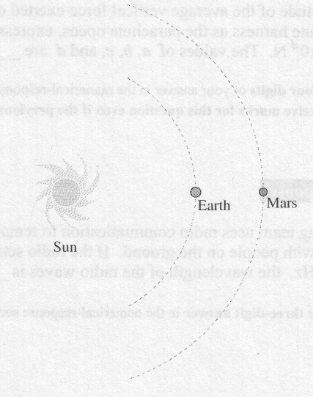

The Mars Polar Orbiter had a total mass of 629 kg. A solar array on the Orbiter provided 500 W of power.

1. When the sun, Earth, and Mars are positioned as shown in the diagram, the time required for a radio signal to travel from Earth to Mars is

A. 21.0 min

B. 12.7 min

C. 8.33 min

D. 4.33 min

1. During an acceleration, a force of 6.00 lb was applied to the Orbiter for 2.50 s. The maximum change in the speed of the Orbiter would have been

A. 1.06 × 10-1 m/s

B. 4.24 × 10-2 m/s

C. 2.38 × 10-2 m/s

D. 5.36 × 10-3 m/s

1. As the Orbiter moved at 5.00 × 103 m/s, it ejected a short burst of fuel perpendicular to its direction of motion. The mass of the Orbiter did not change significantly. If the burst of fuel had a momentum of 1.37 × 105 kg·m/s, then the Orbiter would have been deflected from its original direction by an angle of

A. 0.0436°

B. 2.49°

C. 45.0°

D. 87.5°

____________________________

1. Which of the following is an example of electromagnetic induction?

A. The forces two current‑carrying wires exert on each other

B. The magnetic field produced by a constant current in a wire

C. The forces a magnet and a current‑carrying wire exert on each other

D. The current produced in a wire loop by a changing magnetic field

*Use the following information to answer the next three questions.*

**Television Picture Tube**

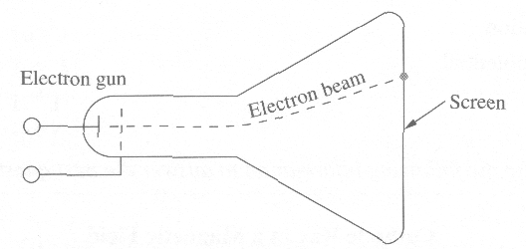

The following is a simplification of what takes place in a television picture tube. The picture tube has an electron gun (left end) shooting a beam of electrons at a fluorescent screen. When an electron beam contacts the screen, the screen glows to produce one dot of the picture. The beam is directed at different parts of the screen to create the entire picture. The electrons have 2.83 × 10-18 J of kinetic energy

A colour television screen contains dots of three different phosphorescent materials that glow red, green, or blue.

Numerical Response

1. Each electron is moving at a speed, expressed in scientific notation, of at least ____× 10*w* m/s.

(Record your **three-digit answer** in the numerical-response section on the answer sheet.)

Numerical Response

1. The voltage that would be required to accelerate each electron, expressed in scientific notation, is ____× 10*w* V.

(Record your **three-digit answer** in the numerical-response section on the answer sheet.)

1. Assume that  represents *B* out ofthe page and  represents *B* into the page. The electrical polarity ofthe electron gun and magnetic field orientation that will cause the electron beam to pass through the tube and deflect upward is shown in

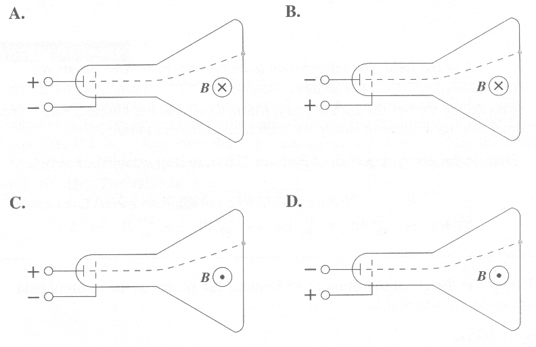

_________________________

1. An electric field of strength 1.5 × 104 N/C is perpendicular to a magnetic field of strength 3.0 × 10-3 T. An electron moves perpendicular to both fields and is undeflected as it passes through the fields. The speed of the electron is

A. 2.0 × 10‑7 m/s

B. 2.0 × 10‑1 m/s

C. 5.0 × 106 m/s

D. 5.0 × 107 m/s

*Use the following information to answer the next question.*

The relative sensitivity of a normal human eye to radiant energy of fixed intensity is illustrated in the graph below.

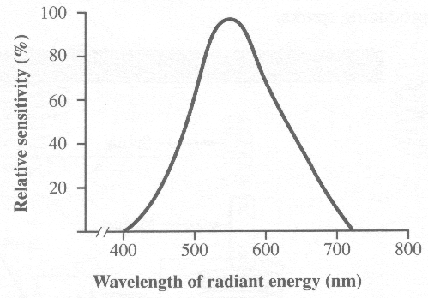

1. The normal human eye shows the greatest sensitivity to

A. ultraviolet light

B. green light

C. violet light

D. red light

_________________________________

1. When two parallel conducting wires repel each other, the currents in the wires are

A. in opposite directions

B. in the same direction

C. oscillating in phase

D. oppositely charged

*Use the following information to answer the next two questions*.

**Solar Wind**

The sun produces a stream of protons, electrons, and other charged particles. When these charged particles enter Earth's magnetic field, they get trapped. If they collide with atoms or molecules in the atmosphere, northern and southern lights occur.

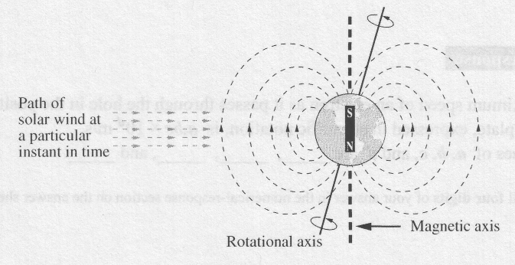

A proton in the solar wind is travelling at 2.5 × 106 m/s perpendicular to Earth's magnetic field. This proton experiences a deflecting magnetic force

of 2.8 × 10-19 N.

1. A proton in the solar wind would experience a magnetic deflecting force that would be represented on the diagram as being directed

A. into the page

B. out of the page

C. toward the top of the page

D. toward the bottom of the page

1. The magnitude of the magnetic field that the proton travels through is

A. 7.0 × 10-7 T

B. 8.0 × 10-7 T

C. 1.3 × 106 T

D. 7.1 × 106 T

______________________________

*Use the following information to answer the next question*.

**Vector Fields**

**I** Gravitational

**II** Electrical

**III** Magnetic

1. Which of the vector fields above are produced by a charged particle at rest?

A. I, II, and III

B. I and II only

C. I and III only

D. II and III only

________________________________

*Use the following information to answer the next question,*

**Unit Combinations**

I. J/C

II. N/(A·m)

III. T

IV. (N·s)/(C·m)

1. Which unit combinations could be used correctly for a magnetic field?

A. I, III, and IV

B. II and III only

C. II and IV only

D. II, III, and IV

______________________________

*Use the following information to answer the next question.*

**Current Flow in a Wire**

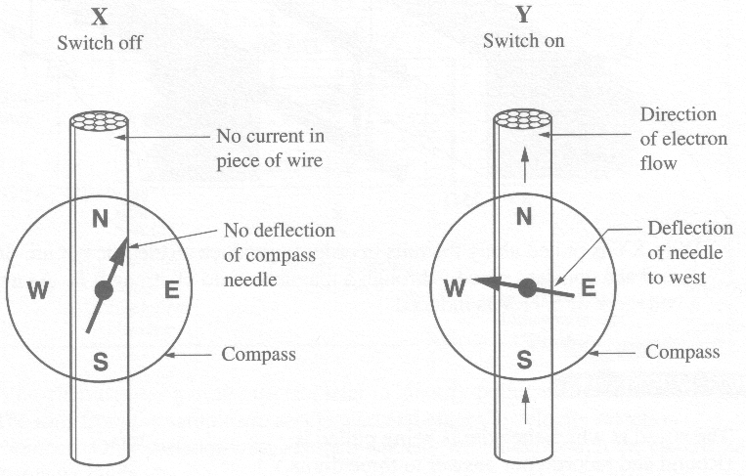

1. If the direction of the electron flow in diagram Y is reversed, the compass needle will point

A. north

B. south

C. east

D. west

_____________________________

1. Compasses are not used to navigate in the Far North because the

A. magnetic field does not extend to the Far North

B. magnetic field is non‑uniform near the Far North

C. magnetic field lines point down to the Earth in the Far North

D. magnetic field lines are parallel to the Earth's surface in the Far North

Numerical Response

1. An electromagnetic wave has a frequency of 2.00 × 1011 Hz. The speed of the wave in a vacuum, expressed in scientific notation, is ______ × 10*w* m/s.

(Record your **three-digit answer** in the numerical-response section on the answer sheet.)

1. In a vacuum, the period of oscillation of a microwave with a wavelength of 2.5 cm is

A. 8.3 × 10‑11 s

B. 8.3 × 10‑9 s

C. 1.2 × 108 s

D. 1.2 × 1010 s

*Use the following information to answer the next question.*

I Oscillating magnet

II Accelerating proton

III Steady electric current

IV Stationary electron

1. The phenomena that produce an electromagnetic wave are

A. I and II

B. I and III

C. II and IV

D. III and IV

______________________________

1. Which of the following regions of the electromagnetic spectrum do **not** overlap?

A. X‑ray and ultraviolet

B. Radar and microwave

C. Microwave and infrared

D. Gamma rays and ultraviolet

*Use the following information to answer the next question*.

**Types of Electromagnetic Radiation (EMR)**

**1** EMR generated by radiation of thermal energy

**2** EMR produced by the rapid deceleration of a fast‑moving electron

**3** EMR associated with a laser light show

**4** EMR emitted during radioactive decay

Numerical Response

1. When the types of electromagnetic radiation above are listed in order from the one with the highest frequency to the one with the lowest frequency, the order is _____, _____, _____ and _____.

(Record all **four digits** of your answer in the numerical‑response section on the answer sheet.)

______________________________

**Answers**

**Multiple choice Numerical Response**

|  |  |  |  |
| --- | --- | --- | --- |
| 1. B 2. D 3. B 4. B 5. B 6. A 7. B 8. D 9. A 10. D 11. A | 1. A 2. D 3. B 4. D 5. A 6. B 7. D 8. D 9. C 10. B 11. A | 1. B 2. A 3. B 4. D 5. C 6. C 7. A 8. A 9. D | 1. 18.7 2. 1.73 3. 3827 4. 1918 5. 1.63 6. 2.49 7. 1.77 8. 3.00 9. 4231 |